Software Requirements Specification

for

E-Toll System
Version 1.0 approved
Prepared by Team KKPA
Team Members
Kritika Soni
Kunal Singhvi
Pavan Kumar Dave
Sharma Anshul Krishan
Team Guide
Mr. Jitendra Sharma
Geetanjali Institute of Technical Studies, Udaipur
30th Dec 2010
Table of Contents
Table of Contents ii
Revision History ii
1. Introduction 1
1.1 Purpose 1
1.2 Document Conventions 1
1.3 Intended Audience and Reading Suggestions 2
  - Project Scope 2
  - References Error: Reference source not found
  - Abbreviations Error: Reference source not found
  - Technologies Error: Reference source not found
  - Overview Error: Reference source not found
2. Overall Description Error: Reference source not found
2.1 Product Perspective Error: Reference source not found
2.2 Product Functions Error: Reference source not found
2.3 User Classes and Characteristics Error: Reference source not found
2.4 Operating Environment Error: Reference source not found
  - Design and Implementation Constraints Error: Reference source not found
  - Use-Case Model Survey Error: Reference source not found
  - Class Diagram Error: Reference source not found
  - Database Diagram Error: Reference source not found
2.6 User Documentation Error: Reference source not found
2.7 Assumptions and Dependencies Error: Reference source not found
3. System Features Error: Reference source not found
  - System Features 1 Error: Reference source not found
  - System Features 2 Error: Reference source not found
  - System Features 3 Error: Reference source not found
4. External Interface Requirements Error: Reference source not found
4.1 User Interfaces 15
4.2 Hardware Interfaces Error: Reference source not found
4.3 Software Interfaces Error: Reference source not found
4.4 Communications Interfaces Error: Reference source not found
5. Other Nonfunctional Requirements 16
5.1 Performance Requirements Error: Reference source not found
5.2 Safety Requirements Error: Reference source not found
  - Security Requirements Error: Reference source not found

Revision History
Name | Date | Reason For Changes | Version

Introduction

Purpose
To automate the toll collection at any toll booth is the main purpose of this project. Along with the tax collection it will provide a user to ensure his vehicle security by providing a unique identity to his vehicle on behalf of his vehicle number. Provided System is an Intranet Application. Thus it facilitates the public to enjoy a break-free ride on highways and to remove government overhead of tax collection.

Document Conventions
This documentation requires font name “Times New Roman” to be installed on notebook or desktop.

Intended Audience and Reading Suggestions
This document is intended for different types of reader, such as developers, project managers, marketing staff, users, testers, and documentation writers. The sequence for reading the document begins with the overview sections and proceeding through the sections that are most pertinent to each reader type.

Project Scope

    - Creates accounts for the vehicle owners who wish to adopt the E-Toll System.
    - Recharge account
    - Easy transaction
    - Vehicle Security
    - Government Authority
    - Facilitates the government
    - Logs
    - overhead, traditional system
    - An online help section is also provided to solve basic issues related to the usages of the application.

References

- IEEE SRS format
- Project Requirement Specifications (As per given by IBM TGMC)

Abbreviations

  - VO: Vehicle Owner, is the owner of the vehicle. He is supposed to pay the tax. He is also the owner of the vehicle account in the system.
- TBE: Toll Booth Executive, is responsible for ensuring the transactions.
- GA: Government Authority,

Technologies
- J2EE: Application Architecture
- DB2: Database
- Eclipse: Development Tool
- WAS: Web Server
- Rational Rose: Design Tool

Overview
SRS includes two sections:

    - Overall description will describe major role of the system components and Interconnection's.
    - Specific requirements will describe roles & functions of the actors.

Overall Description

Product Perspective
This is a dynamic way to automate collection of toll tax at government owned toll booths. It simplifies the overhead of manual receipt procedure and the tradtitional system running by the date. The system encorporates the RFID Technology that enable automatic detection of vehicles.

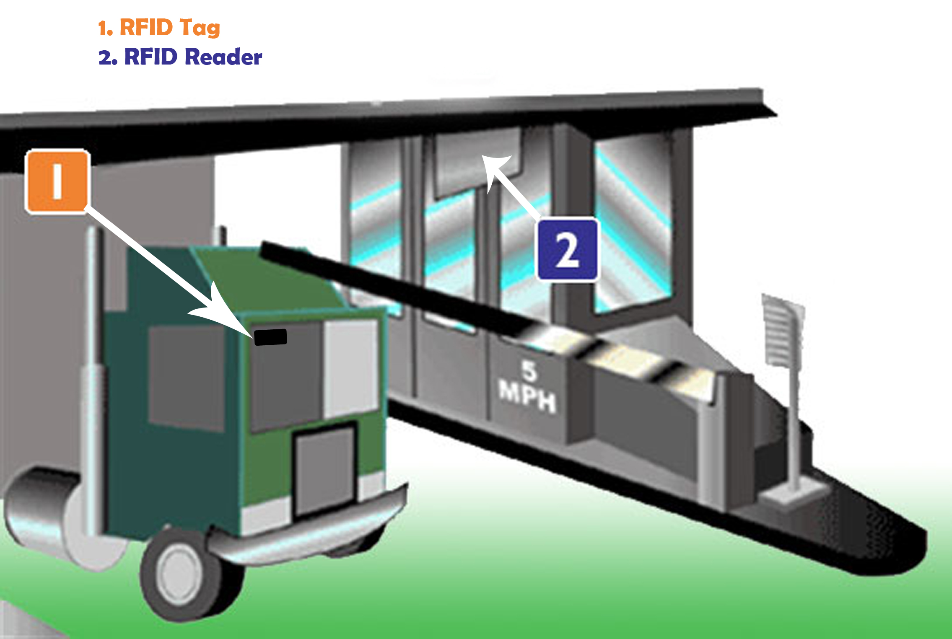
- The web pages (JSP) resides in the application is hosted at web server provides the user interface.
- HTTP/HTTPS protocol is used while accessing the web application either by clients or system users.
- TCP/IP protocol is used when web server access the database server.
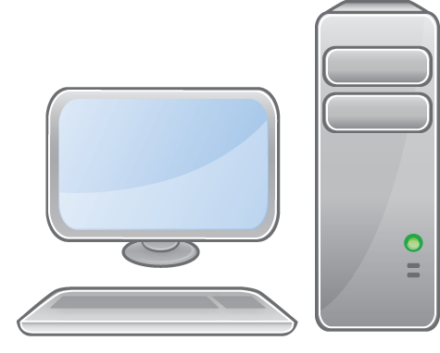






Vehicle Owner
Toll Booth Executive
Govt. Authority
WAS
Web Server
DB2 Server
http/https
http/https
http/https
tcp/IP
tcp/IP

Product Functions
Module | Function
Sign_Up | Used to create an account of the VO
Store_DB | Maintain the database of the provided during the sign-up process. The data is well verified and fed in by the government authority
Create_Xsaction | When the car is detected this module is responsible for the TRANsactiononey from the user account to the government
Create_Log | Module helps to create log of all the passed cars
View_Log | Enables the tbe to keep track of vehicles passing bye
Recharge_Acc | Module recharges the vo acc by certain amount

User Classes and Characteristics
Every user should be comfortable of working with computer and net browsing. He must have basic knowledge of English too.

Operating Environment
The software will operate in the operating system matching to the given system hardware and with sufficient system feature to make latest software run smoothly.

Design and Implementation Constraints
- Corporate or regulatory policies should be kept under consideration.
- Timing of the processor should be matching the hardware implemented by the developer.
- Multi-threading systems will enable simultaneous operations thus a developer can perform many tasks at a time.
- Tools such as visual studio and sql server should be updated regularly,
- All the protocols should be enabled at the basic level to avoid any discrepancies.
- Firewall setting should be made in accordance with the browser to enable the working of the website.

Use-Case Model Survey
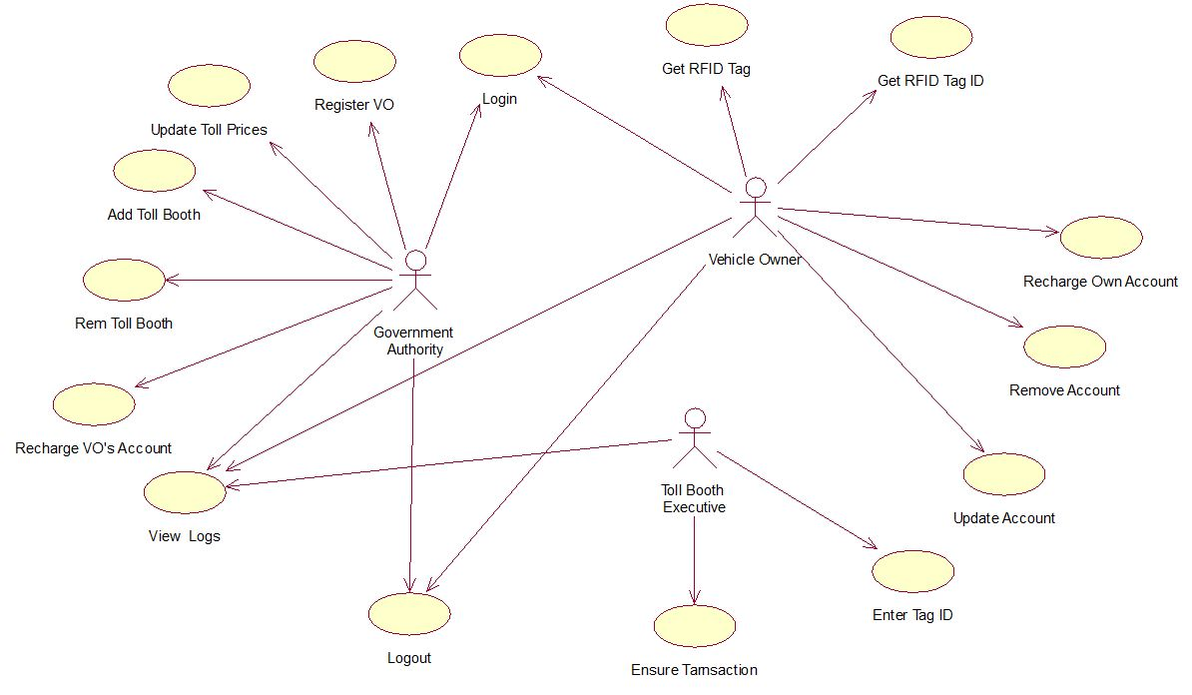

Class Diagram

Database Diagram

User Documentation

      - User documentation components such as user manuals, on-line help will be delivered along with the software.
      - A self-controlled downloadable flash file is available along with the application.

Assumptions and Dependencies

      - It is assumed that user is familiar with the basic computer fundamentals.
      - Timely backup of data should be taken to avoid data loss in case of system crash.
      - The use of pirated software should be avoided as it may lead to data loss and system crashes due to viral infections.
      - Floppies and other removable media should be scanned for viruses before use.
      - Proper configuration of the client, database server and network is necessary for the system to function as intended.
      - It is assumed that the maintenance of the database will be assigned to the authorized person only.
      - Only authorized persons will be allowed inside the server room.

System Features
The organizational functional requirement for the product and major services provided by the product are explained by the use of use-case and activity diagram

Recharge and Register (GA's Feature )
    - Description and Priority
Provided by the government authority who has been assigned the work to make an account of the vehicle owner and verify his details which are added to his account profile. long side this is at the highest priority for the vehicle owner as he is required to complete this task to be able to use the e-toll system
    - Stimulus/Response Sequences







VO
GA

use cases.>

3.1.3 Functional Requirements
The details of the feature is shown below with their possibility to opt for the service architecture.

- The tag allocated by the GA should not conflict with any other card
- the validation of the user should be done with the documents provided by the VO

Tracking (TBE's Feature )
3.2.1 Description and Priority
The track of the vehicles passing by the toll booths and their verification of their transaction is done by the TBE. This feature is of the less priority as it may not happen that a vehicle may not pass by the tag-reader without transaction. This is a feature which may help us to keep track of the vehicles passing by the toll booth thus providing a security and a satisfaction to the government.
3.3.2 Stimulus/Response Sequences
TBE Passing car










The user defined works are shown below

3.2.3 Functional Requirements

- The log of vehicles clearing the booth is always displayed on the computer
- Facility of inter booth communication is provided via phone network
- Alarming functionality is is also required to signal true or false

VO account(VO's Feature)

3.3.1 Description and Priority
to enable the user to use this e-toll system he registers himself and is able to access different functionality of the online system. He gets a username and password to access this website. The VO is required to complete this process to proceed to automatic transactions.
3.3.2 Stimulus/Response Sequences
VO Account features



The VO defined works are shown below
3.3.3 Functional Requirements

- The user must b able to access the site from computer
- He must own a credit card to recharge online

External Interface Requirements

User Interfaces
- The system will be having user privileges based menu.
- User will have to select the option from the given menu.
- The system will be entering the information into the database to generate reports.
- The forms will be designed to enter the data.
- Buttons will be used to insert, retrieve or modify the data.
- Links will be provided to shift from one form to another.

Hardware Interfaces

Client Side

 | Processor | RAM | Disk Space
Internet Explorer 6.0, Mozilla firefox, Chrome | Pentium II at 500MHz | 64 MB | 1GB
Sever Side
SQL server | Pentium III at 1GHZ | 512MB | 1GB(excluding data size)

Software Interfaces
- Client on Internet: Web Browser, Operating System (any)

- Client on Intranet: Client Software(RFID Vendor's Software), Web Browser, Operating System (any)

- Web Server: WAS, Operating System (any)

- Data Base Server: DB2 Express-C, Operating System (any)

- Development End: Eclipse (J2EE, Java, Java Bean, Servlets, HTML), DB2, OS (Windows), Web Server.

Communications Interfaces
Client on Intranet and Client on Intranet will be using HTTP/HTTPS protocol.

Other Nonfunctional Requirements

Performance Requirements
The given system should be enabled with real time browser for the smooth working of the application.

Safety Requirements
Proper safety measures should be made and proper care should be made as described below:

- Safeguards against voltage fluctuation should be made to protect the hardware
- A protection against the virus malwares etc. should be made with duly updated antivirus software.
- Proper safety for the database should be made and the database should be updated
- and backed up regularly.

Security Requirements
- Regarding security or privacy issues surrounding use of the product or tprotection of the darta used or created
- Regarding security or privacy issues surrounding use of the product or protection of the data used or created by the product should be made according to the rules specified by the government.
- Authentications should be made correctly to avoid misuse of the data

